Implement an external task worker
After modeling the process, we want to execute some business logic.
Camunda Platform is built so that your business logic can be implemented in different languages. You have the choice which language suits your project best.
In this quick start, we’ll show you how to use Camunda’s ready-to-go task clients in:
- Java
- JavaScript (NodeJS)
If you’ve never worked with Java before, we recommend using the JavaScript (NodeJS) task client in this tutorial.

Hint
If you prefer a different programming language, you can also use Camunda’s REST API to access API operations via HTTP.

a) Using Java
In this section, you’ll learn how to implement an external task worker in Java.

Prerequisites
Make sure you have the following tools installed:
- JDK 1.8
- An IDE for Java projects (e.g. Eclipse)

Create a new Maven project
Start by creating a new Maven project in your IDE.
If you’re using Eclipse, you can follow these steps:
In Eclipse, go to File / New / Other …. This opens the New Project Wizard. In the New Project Wizard, select Maven / Maven Project. Click Next.
On the first page of the New Maven Project Wizard, select Create a simple project (you can skip archetype selection). Click Next.
On the second page (see screenshot), configure the Maven coordinates for the project. Since we are setting up a JAR Project, make sure to select Packaging: jar.
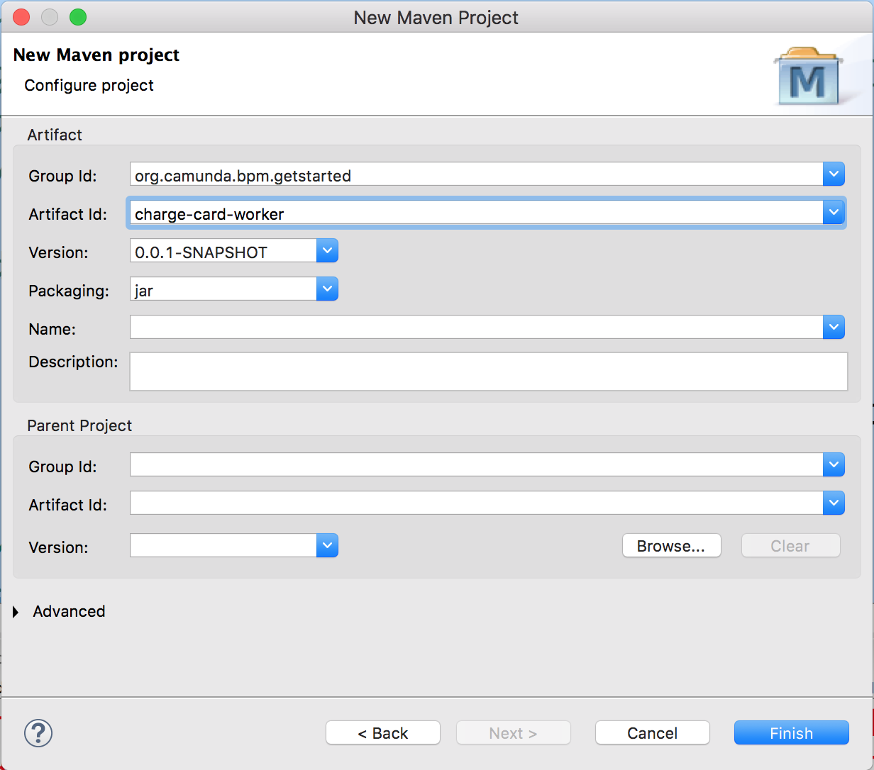
When you’re done, click Finish. Eclipse will set up a new Maven project. The project appears in the Project Explorer View.
If you’re using IntelliJ, you can follow these steps:
- If no project is currently open in IntelliJ IDEA, click New Project on the Welcome screen. Otherwise, select File | New | Project from the main menu.
- Select Maven from the options on the left.
- Specify project's SDK (JDK) or use the default one and an archetype if you want to use a predefined project template (configure your own archetype by clicking Add Archetype ).
Click Next.
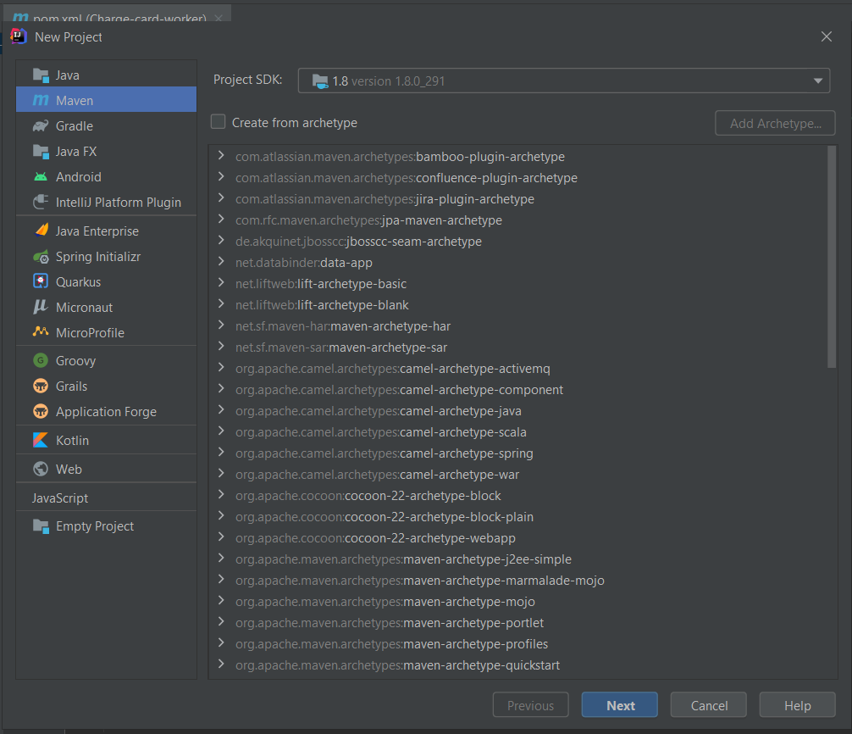
- On the next page of the wizard, specify the following Maven coordinates that are added to the pom.xml file:
  - GroupId- org.camunda.bpm.getstarted (a package of a new project).
  - ArtifactId- charge-card-worker (a name of your project).
  - Version- a version of a new project. By default, this field is specified automatically.
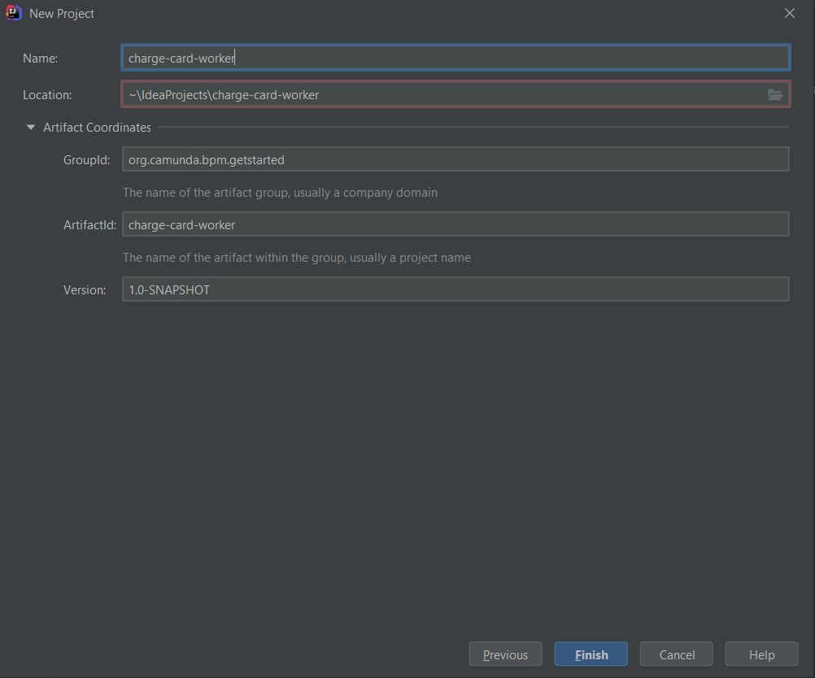
For more information on Maven coordinates, see Maven naming conventions.
Click Next.
- If you are creating a project using a Maven archetype, IntelliJ IDEA displays the Maven settings that you can use to set the Maven home directory and Maven repositories. Also, you can check the archetype properties.
Click Next.
- Specify the name and location settings.
Click Finish.
IntelliJ IDEA creates a Maven project with the pom.xml file that includes compiler and target versions of Java, dedicated Maven tool window, and all the necessary dependencies to start you work.
The version of Java specified in the pom.xml file overrides the version specified in the JDK for Importer option, located in the Maven settings.

Add Camunda External Task Client Dependency
The next step consists of setting up the Maven dependency to the external task client for your new process application. Your pom.xml file of your project should look like this:
<project xmlns="http://maven.apache.org/POM/4.0.0" xmlns:xsi="http://www.w3.org/2001/XMLSchema-instance"
xsi:schemaLocation="http://maven.apache.org/POM/4.0.0 http://maven.apache.org/xsd/maven-4.0.0.xsd">
<modelVersion>4.0.0</modelVersion>

<groupId>org.camunda.bpm.getstarted</groupId>
<artifactId>charge-card-worker</artifactId>
<version>0.0.1-SNAPSHOT</version>

<dependencies>
<dependency>
<groupId>org.camunda.bpm</groupId>
<artifactId>camunda-external-task-client</artifactId>
<version>7.15.0</version>
</dependency>
<dependency>
<groupId>org.slf4j</groupId>
<artifactId>slf4j-simple</artifactId>
<version>1.6.1</version>
</dependency>
<dependency>
<groupId>javax.xml.bind</groupId>
<artifactId>jaxb-api</artifactId>
<version>2.3.1</version>
</dependency>
</dependencies>
</project>

Add the Java class
Next, we will create a new ExternalTaskClient which subscribes to the charge-card topic.
When the process engine encounters a service task that is configured to be externally handled, it creates an external task instance on which our handler will react. We are using Long Polling in the ExternalTaskClient to make the communication more efficient.
Next, you need to create a package, e.g., org.camunda.bpm.getstarted.chargecard and add a Java class, e.g. ChargeCardWorker, to it.
package org.camunda.bpm.getstarted.chargecard;

import java.util.logging.Logger;
import java.awt.Desktop;
import java.net.URI;

import org.camunda.bpm.client.ExternalTaskClient;

public class ChargeCardWorker {
private final static Logger LOGGER = Logger.getLogger(ChargeCardWorker.class.getName());

public static void main(String[] args) {
ExternalTaskClient client = ExternalTaskClient.create()
.baseUrl("http://localhost:8080/engine-rest")
.asyncResponseTimeout(10000) // long polling timeout
.build();

// subscribe to an external task topic as specified in the process
client.subscribe("charge-card")
.lockDuration(1000) // the default lock duration is 20 seconds, but you can override this
.handler((externalTask, externalTaskService) -> {
// Put your business logic here

// Get a process variable
String item = (String) externalTask.getVariable("item");
Long amount = (Long) externalTask.getVariable("amount");

LOGGER.info("Charging credit card with an amount of '" + amount + "'€ for the item '" + item + "'...");

try {
Desktop.getDesktop().browse(new URI("https://docs.camunda.org/get-started/quick-start/complete"));
} catch (Exception e) {
e.printStackTrace();
}

// Complete the task
externalTaskService.complete(externalTask);
})
.open();
}
}

Run the worker
You can run the Java application by right clicking on the class ChargeCardWorker and choosing Run as Java.
Note that the worker should remain running throughout the entirety of this quick start guide.

Next Step
Once your worker is running, you can continue to deploy your process and start some instances.

Deploy the Process
In the next step, you’ll deploy the Process and start a new instance so you can see that your simple process is working correctly.

Use the Camunda Modeler to Deploy the Process
In order to deploy the Process, click on the deploy button in the Camunda Modeler, then give it the Deployment Name “Payment Retrieval” and click the Deploy button. From version 3.0.0 on, you will be required to provide an URL for an Endpoint Configuration along with Deployment Details. This can be either the root endpoint to the REST API (e.g. http://localhost:8080/engine-rest) or an exact endpoint to the deployment creation method (e.g. http://localhost:8080/engine-rest/deployment/create).
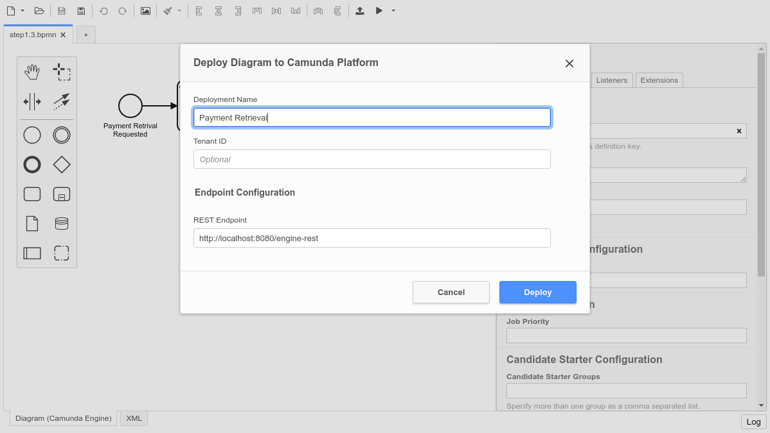You should see a success message in the Camunda Modeler: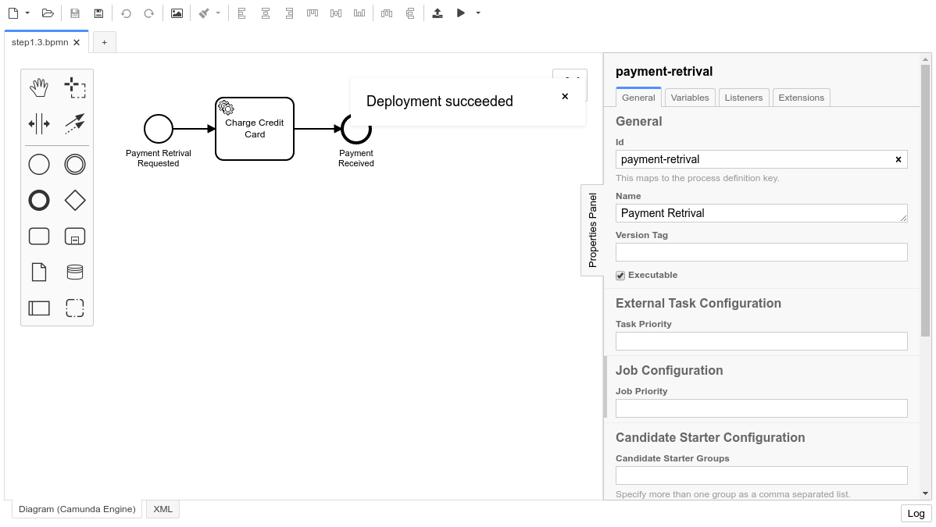

Verify the Deployment with Cockpit
Next, use Cockpit to see if the process was successfully deployed. Go to http://localhost:8080/camunda/app/cockpit and log in with the credentials demo / demo. Your process Payment Retrieval should be visible on the dashboard.
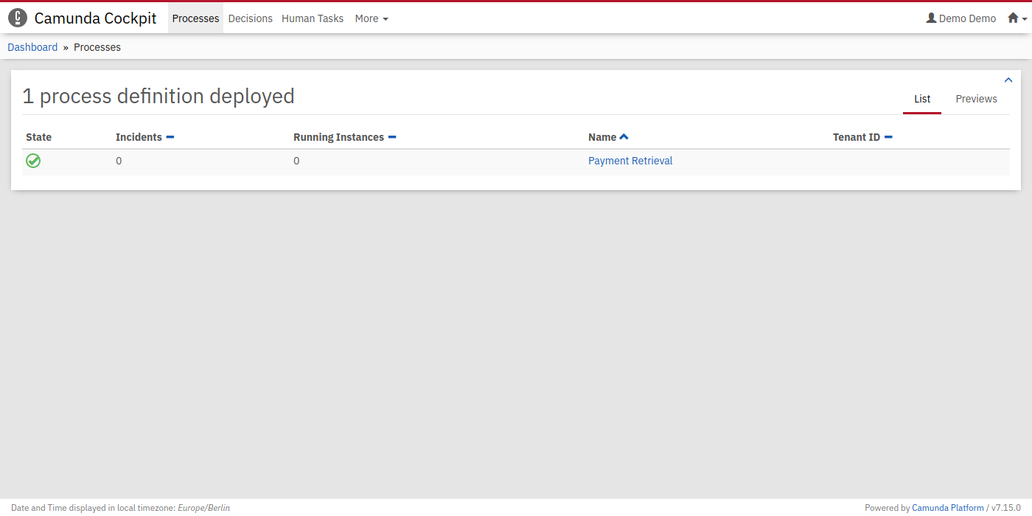

Start a Process Instance
In Camunda, there are different ways to start a new process instance. You can leverage the Camunda REST API to start a new process instance by sending a POST Request.

a) curl
curl -H "Content-Type: application/json" -X POST -d '{"variables": {"amount": {"value":555,"type":"long"}, "item": {"value":"item-xyz"} } }' http://localhost:8080/engine-rest/process-definition/key/payment-retrieval/start
In your worker, you should now see the output in your console. This means you have successfully started and executed your first simple process.

b) REST Client
If you don’t feel comfortable using curl for the REST request, you can instead make use of any REST client.
Make a POST request to the following endpoint: http://localhost:8080/engine-rest/process-definition/key/payment-retrieval/start
The JSON Body should look like this:
{
"variables": {
"amount": {
"value":555,
"type":"long"
},
"item": {
"value": "item-xyz"
}
}
}
Hint: Make sure you are setting the headers correctly to Content-Type: application/json
Here’s what the request might look like in Postman:
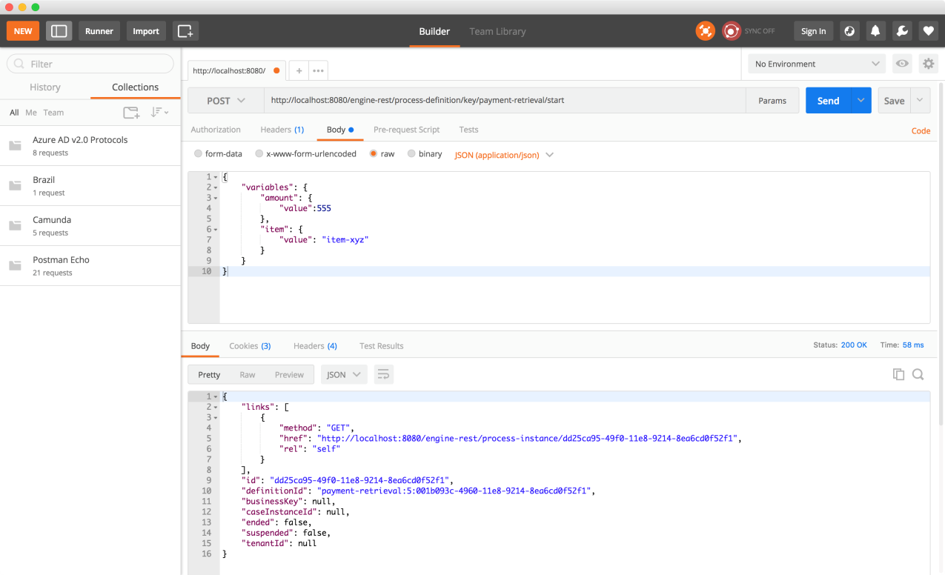
In your worker console (which we started in the previous section), you should now see an output. This means you have successfully started and executed your first simple process.

Hint
If you are running on Camunda Enterprise Edition, you can also check out your completed process instance in the Camunda Cockpit.

Next Step
In some cases, we’ll want to involve humans in our process.

Add a User Task to the Process
In this section, you’ll learn how to involve humans in your process by using BPMN 2.0 User Tasks.

Add a User Task
We want to modify our process so that we can involve humans.
To do so, open the process in the Camunda Modeler.
Next, from the Modeler’s left-hand menu, select the activity shape (rounded rectangle) and drag it into position between the Start Event and the “Charge Credit Card” Service Task. Name it Approve Payment.
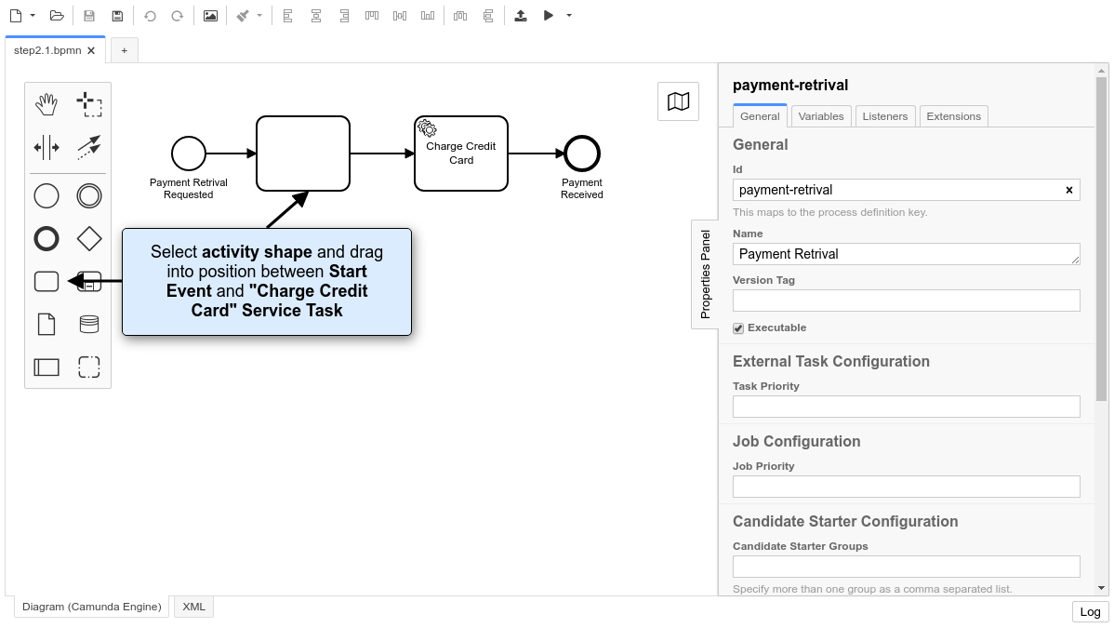
Change the activity type to User Task by clicking on it and using the wrench button menu.
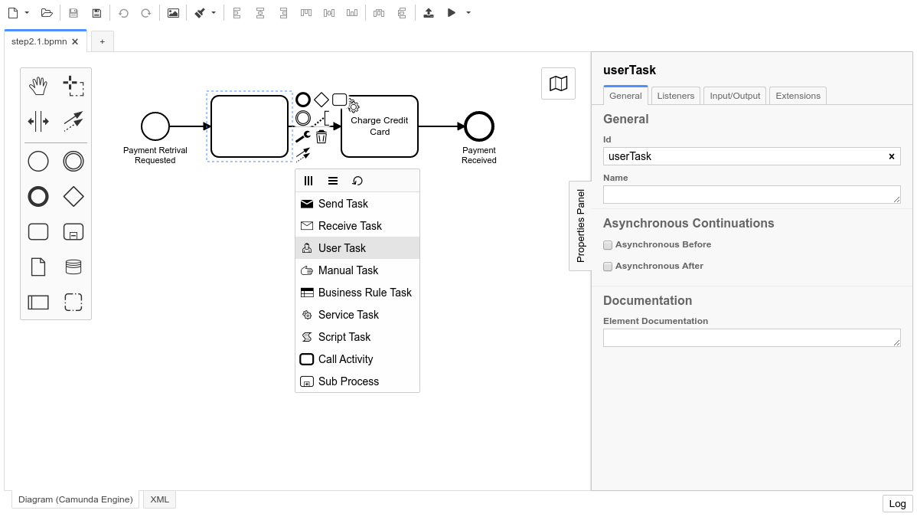

Configure a User Task
Next, open the properties view. If the properties view is not already visible, click on the “Properties Panel” label on the right-hand side of the Modeler canvas.
Select the User Task on the canvas. This will update the selection in the properties view. Scroll to the property named Assignee. Type demo.
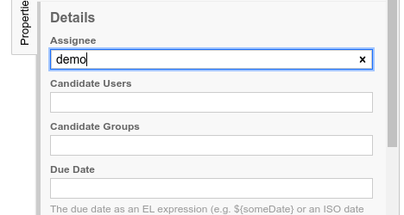

Configure a basic form in the User Task
This step will also take place in the properties panel. If the panel is not already visible, click on the “Properties Panel” label on the right-hand side of the Modeler canvas.
Select the User Task on the canvas. This will update the selection in the properties view.
Click on the Tab Forms in the properties panel.
Add three form fields by clicking on the plus button:
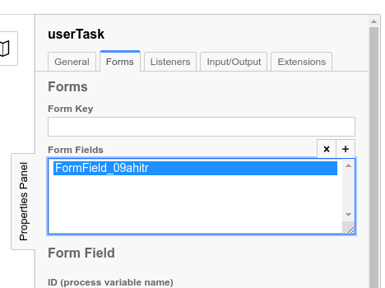
Field 1:
- ID: amount
- Type: long
- Label: Amount
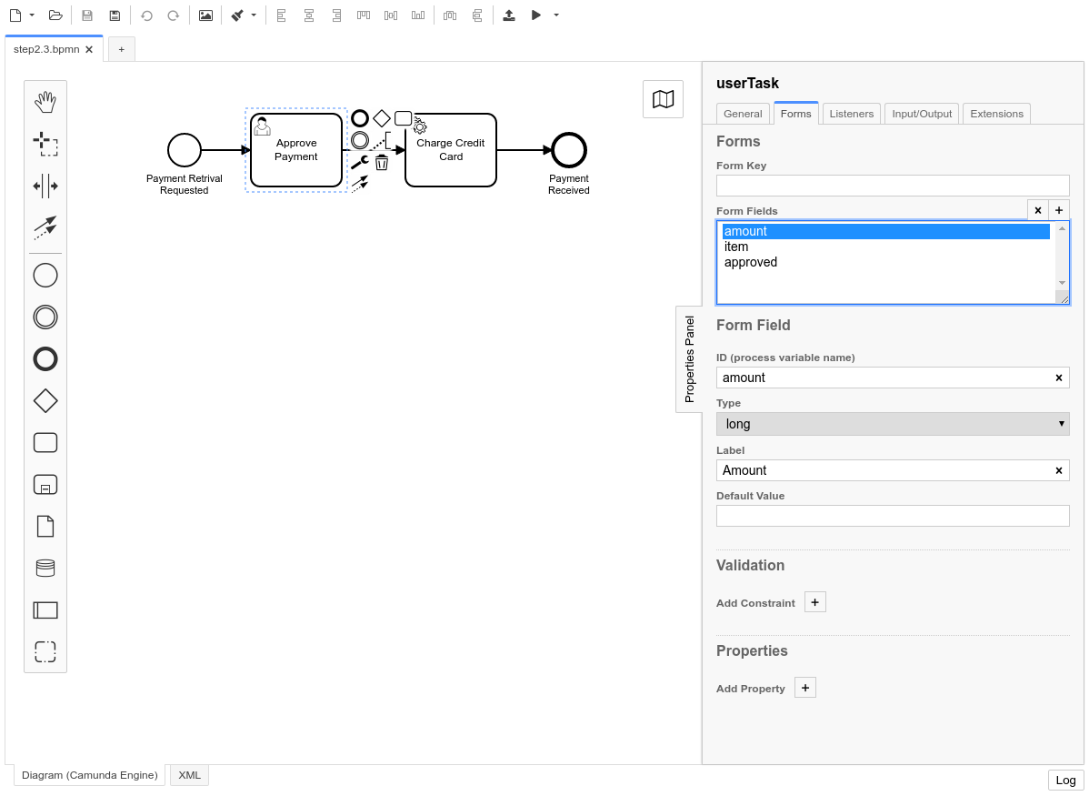
Field 2:
- ID: item
- Type: string
- Label: Item
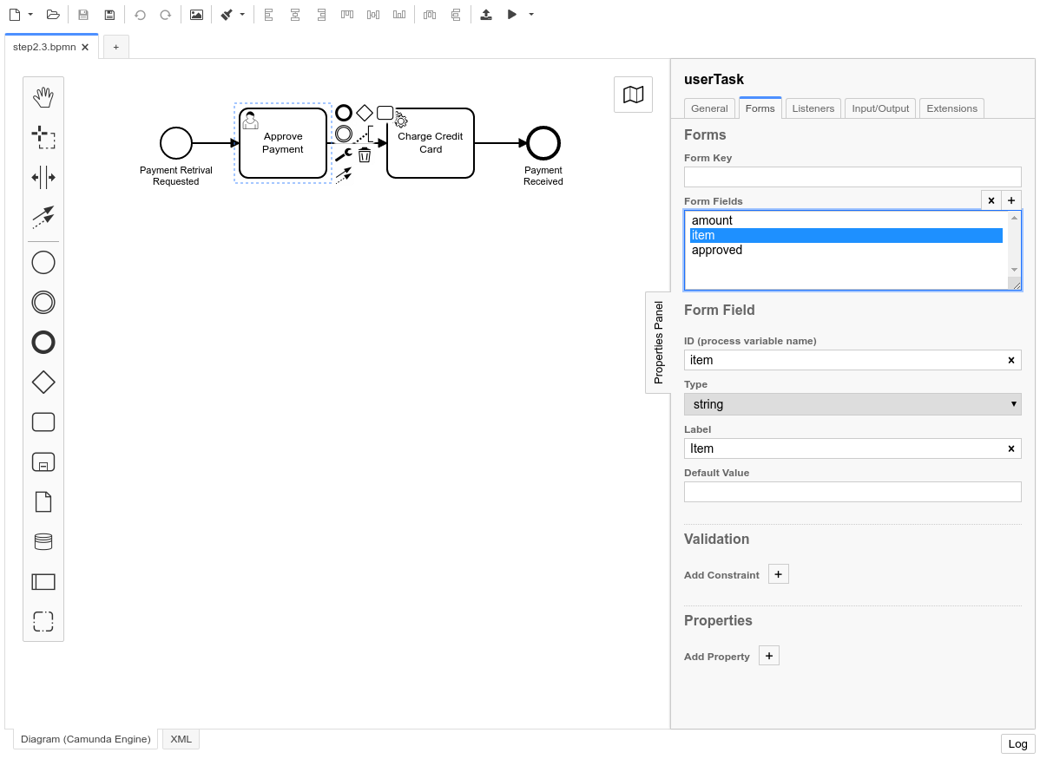
Field 3:
- ID: approved
- Type: boolean
- Label: Approved?
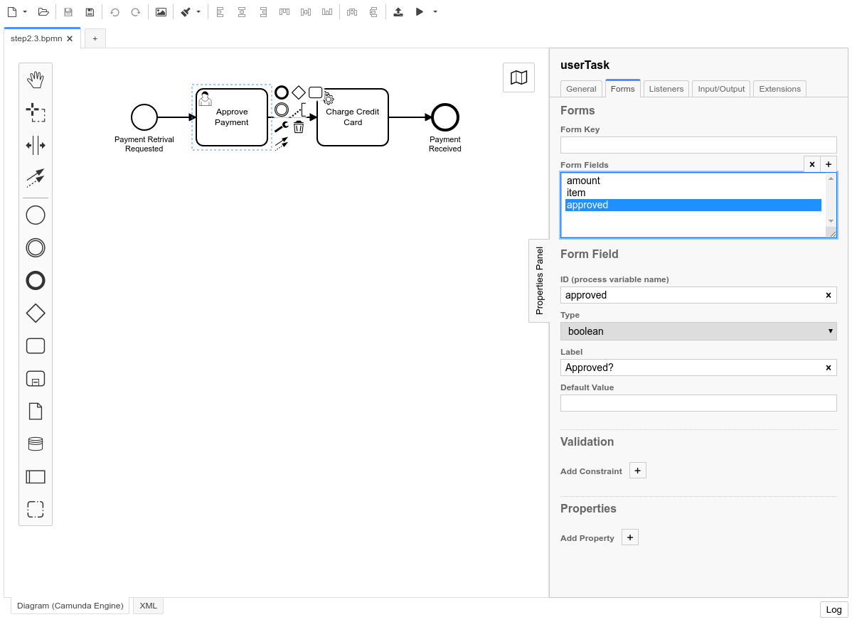

Deploy the Process
Use the Deploy Button in the Camunda Modeler to deploy the updated process to Camunda.

Work on the Task
Go to Tasklist (http://localhost:8080/camunda/app/tasklist/) and log in with the credentials “demo / demo”. Click on the Start process button to start a process instance. This opens a dialog where you can select Payment Retrieval from the list. Now you can set variables for the process instance using a generic form.
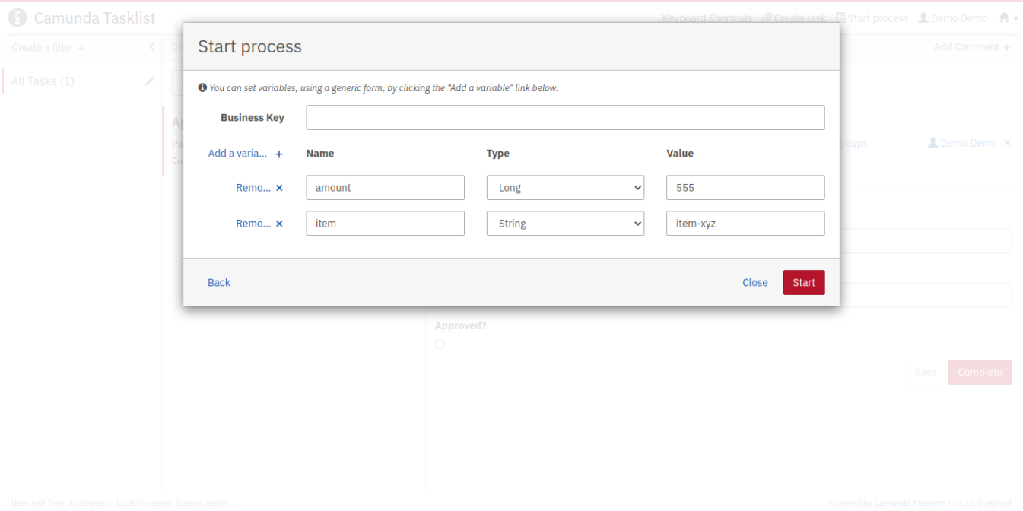
The generic form can be used whenever you have not added a dedicated form for a User Task or a Start Event. Click on the Add a variable button to create a new row. Fill in the form as shown in the screenshot. When you’re done, click Start.
You should now see the Approve Payment task in your Tasklist. Select the task and click on the Diagram tab. This displays the process diagram highlighting the User Task that’s waiting to be worked on.
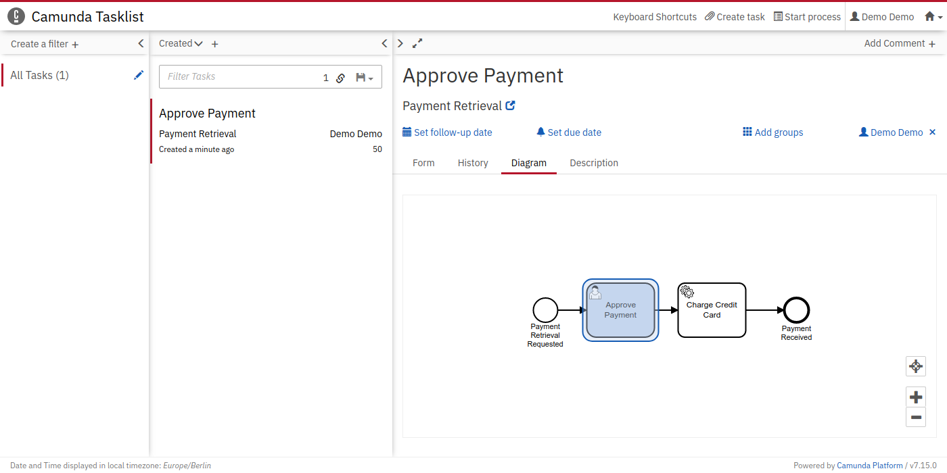
To work on the task, select the Form tab. Because we defined the variables in the Form Tab in the Camunda Modeler, the Tasklist has automatically generated form fields for us.
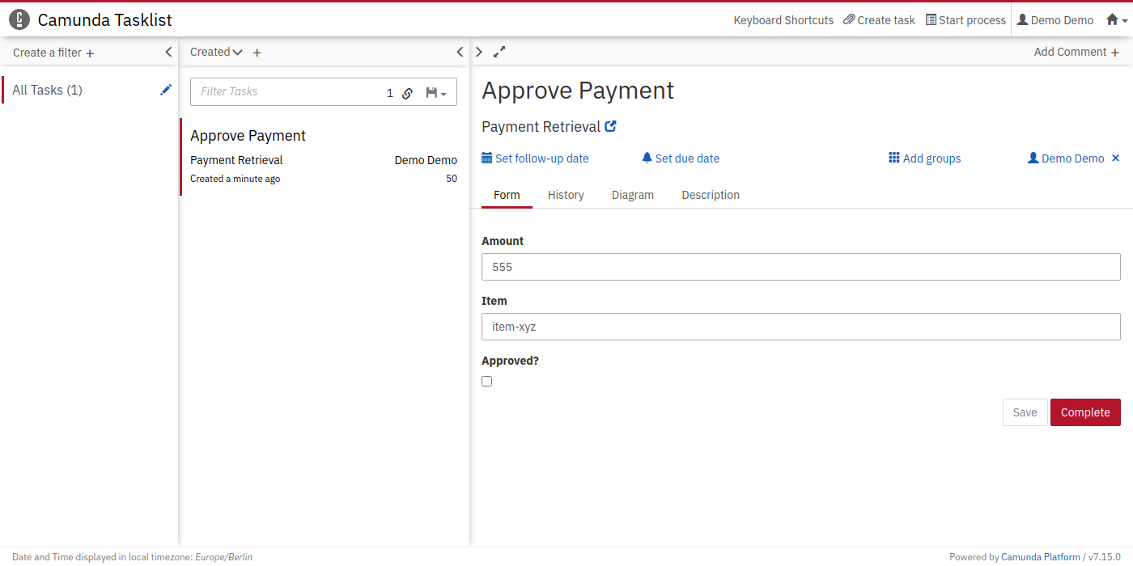

Next Step
Next, we’ll make the process more dynamic and only show a User Task in certain situations. Let’s have a look how you can add Gateways to your Process.

Add Gateways to the Process
In this section, you’ll learn how to make your process more dynamic by using BPMN 2.0 Exclusive Gateways.

Add Two Gateways
We want to modify our process so that it’s more dynamic.
To do so, open the process in the Camunda Modeler.
Next, from the Modeler’s left-hand menu, select the gateway shape (diamond) and drag it into position between between the Start Event and the Service Task. Move the User Task down and add another Gateway after it. Lastly, adjust the Sequence Flows so that the model looks like this:
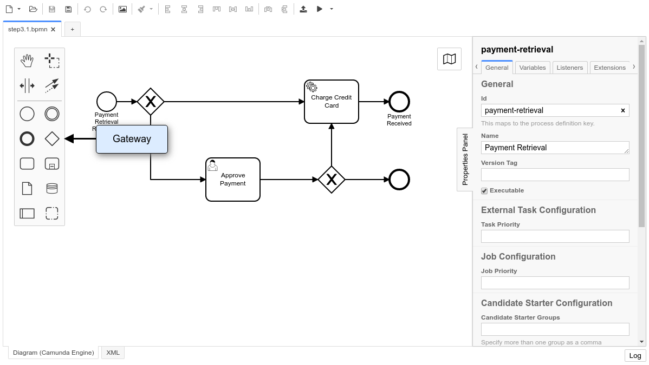
Now also name the new elements accordingly:
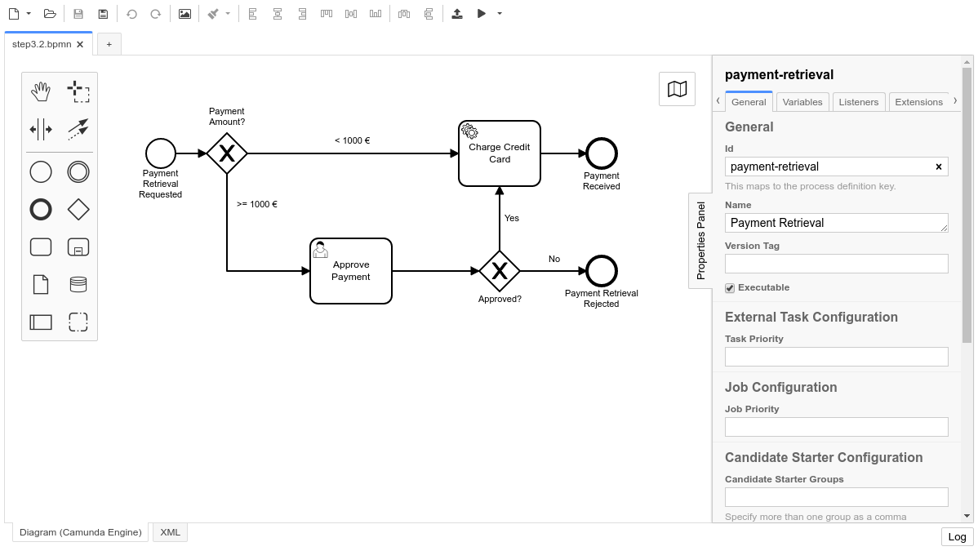

Configure the Gateways
Next, open the properties panel and select the <1000 € Sequence Flow after the Gateway on the canvas. This will update the selection in the properties panel. Scroll to the property named Condition Type and change it to Expression. Then input ${amount<1000} as the Expression. We are using the Java Unified Expression Language to evaluate the Gateway.
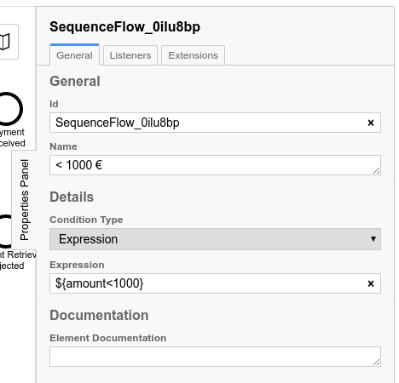
Next, change the Expressions for the other Sequence Flows, too.
For the >=1000 € Sequence Flow, use the Expression ${amount>=1000}:
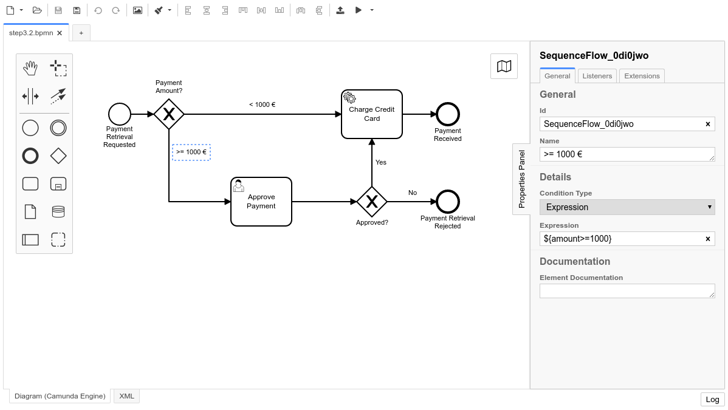
For the Yes Sequence Flow, use the Expression ${approved}:
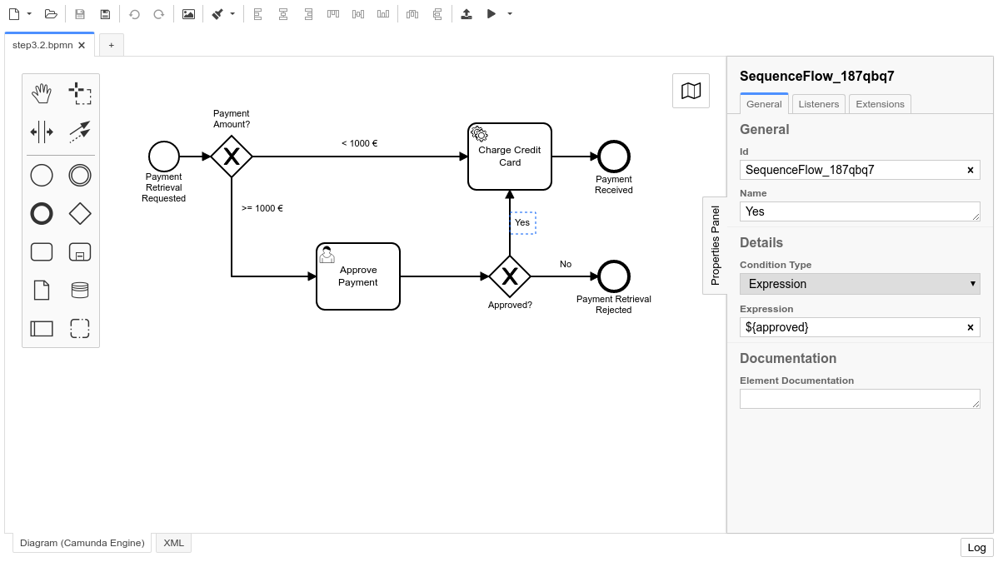
For the No Sequence Flow, use the Expression ${!approved}:
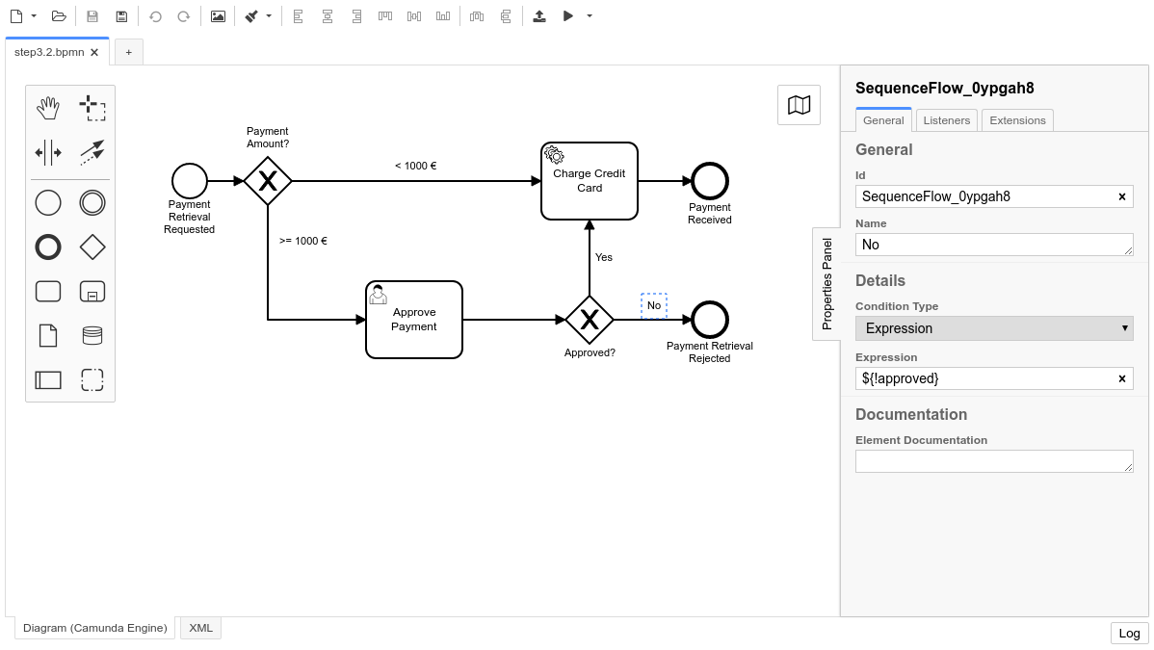

Deploy the Process
Use the Deploy Button in the Camunda Modeler to deploy the updated process to Camunda.

Work on the Task
Go to Tasklist (http://localhost:8080/camunda/app/tasklist/) and log in with the credentials “demo / demo”. Click on the Start process button to start a process instance for the Payment Retrieval Process. Next, set variables for the process instance using the generic form as we learned in the User Tasks section.
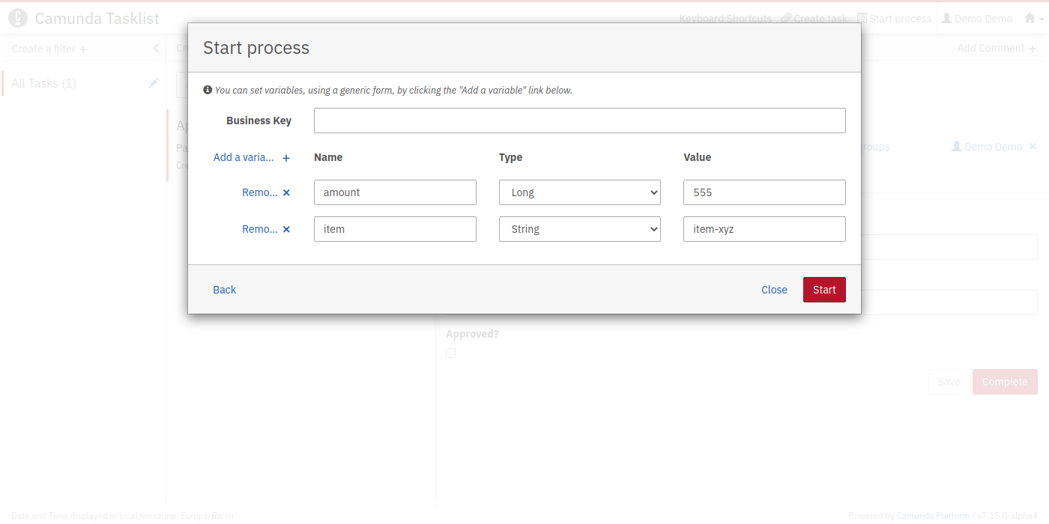
Fill in the form as shown in the screenshot and make sure you use an amount that is larger or equal to 1000 in order to see the User Task Approve Payment. When you are done, click Start.
You should see the Approve Payment task when you click on All Tasks. In this quick start, we’re logged into Tasklist as an admin user, and so we can see all tasks associated with our processes. However, it’s possible to create filters in Tasklist to determine which users can see which tasks based on user authorization as well as other criteria.
To work on the task, select the Form tab and check the approved checkbox so that our payment retrieval gets approved. We should see that our worker prints something to the console.
Next, repeat the same steps, and this time, reject the payment. You should also create one instance with an amount less than 1000 to confirm that the first gateway works correctly.

Next Step
Now you’re ready for Decision Automation.

